You can find code here

<https://github.com/mahbuburriad/lung_cancer>

[Download Link](https://codeload.github.com/mahbuburriad/lung_cancer/zip/master)

run it by MATLAB

Explanation of code: (Line by line)

First all of, take the image from your pc’s drive for read the image. Then convert the whole image pure black and white which value is 0.7. you can all do whatever you want to convert to whatever color by changing value but black and white is standard because in many x-ray and other operation’s lab all image is black and white. Then label the both color that means one is white and another is black. Because need to separate the white from the black for marking and research. Then used “region props” to measure label of image’s area and mark the tumor area solid. And make it pure solid. Because tumor already has much higher solidity in brain. Then measure the density and measure all from the solid area. Then used 50% values (for last stage). but for lower stage need to solve to measure the values in small like 20%. Then measure the max area and find tumor label and now used morphological operation using dealation (it’s very basic) used for boundary the area and select the area of tumor and show result just need to make sure that all should be in pure solid. (this is optional, if you want to use or not does not matter)

Future Improvement: (important)

For Future improvement (to do better result needed algorithm list (maybe will use or not but need to do better result)

Histogram Equalization algorithm – to improve image contrast. (I think this will need for very lower stage. Because many effected areas do not see clear and will not solid area in MATLAB without higher contrast)

If use Histogram then need Adaptive histogram equalization because it adapts to local change in contrast (which is mark for non-effective area that means (from divide non-effective area to effective area)

For segmentation area we need maybe Segmentation algorithm. Which are

Random walker algorithm

Region growing

Watershed transformation – a class of algorithm on the watershed analogy (from divide blood to solid area)

Result:

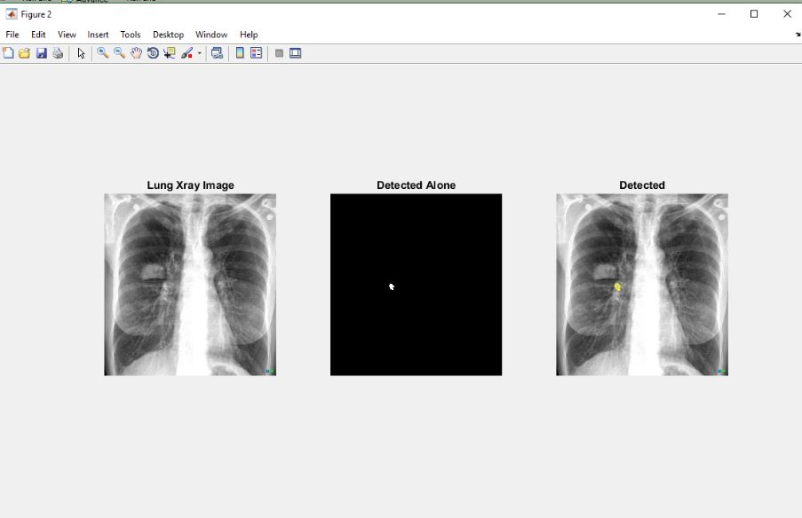

Mam Need to Lean Open CV and Need to learn about lungs cancer.

We just detect the tumor. If really depends on tumor then I can be doctor by 1 day :D